Tłįcho communities: Behchokǫ̀, Gamètì , Wekweètì and Whatì.
Behchokǫ̀ is the largest Tłįcho community with approximately 1950 people. It consists of two distinct townsites: Rae located on Marion Lake, is the main community where most of the people and services are located, and Edzo, a small “bedroom” community located just off of Highway No. 3. Behchokǫ̀ houses the central offices for the Tłįcho Government and the Tłįcho Community Services Agency.
The communities of Gamètì, Wekweètì and Whatì are beautiful, isolated, and smaller communities located inland off the main NWT highway system and are only accessible by regular scheduled commercial air service all year round. However in the winter, from January through March, an ice road highway is built across the tundra and frozen lakes joining these communities to Highway No.3.
Today, many residents are employed in Tłįcho companies, in local government and business, or work on rotation at the diamond mines, some 300 km north of the community.

Population (2005)  1,951 | Primary Language (2004)  93.1% speak Tłįcho | Traditional Activities (2003)  35.3% Hunting & Fishing  15.1% Trapping  38%Consuming Country Foods

Edzo was named after a historical Tłįcho leader who arranged peace between the Tłįcho and the Yellowknives. Development of Edzo begin in 1965 by the government, to attract residents from Rae to the new community, however many chose to remain in Rae, where hunting, fishing and trapping were more accessible. Today Edzo, is a largely a residential community and home to the Chief Jimmy Bruneau Regional High School. Edzo is located just off of Highway No. 3 and is about 15 km by road from Rae.
Today, many younger residents are employed in Tłįcho companies, in local government and business, or work on rotation at the diamond mines, some 300 km north of the community. However the traditional lifestyle based upon traditional pursuits remains important in Behchokò and hunting, fishing and trapping remain parts of the livelihood of many of our people.

The annual journey by canoe to this “gathering” is called “Trails of Our Ancestors.”
Young people travel with their elders along the rivers and lakes of their homeland. Along the way, they learn about the traditional trails and hear stories about the sacred places, gravesites and history of their people, and learn about the traditional uses of many plants and animals.
When the canoes arrived in Behchokǫ, Northwest Territories, they were welcomed by their hosts. The annual gathering is an important part of the Tłı̨chǫ government because it provides an opportunity for citizens to ask questions, provide recommendations and offer direction to the elected chiefs and Assembly members.
Our communities are home to a variety of businesses. There are some private businesses that provide basic services to the members of their community such as taxi services, a bed and breakfast in Whatì and convenience stores in Behchokö and Whatì. The small size of the markets in each community can create real challenges for private entrepreneurs so most businesses are owned by the Tlicho people under the umbrella of our Tlicho Investment Corporation. These "tribal" businesses also offer services to members of the community, but others are much larger, offering services of various kinds to industry across the north.
Our communities are also home to many talented craftspeople and artists who create beautiful and functional traditional crafts, paintings,
Behchoko is a small community on the Mackenzie Highway surrounded by boreal forest and lakes. It is the largest Tlicho community and is the base for education and several government structures in the Tlicho region. Behchoko is actually two communities that used to be called Rae and Edzo. The newly named Behchoko is only about a hundred kilometres from the territory’s capital of Yellowknife to give it access urban amenities. The name Behchoko means, “big knife place” in the Tlicho language and is thought to be due to the trade of items such as knives in the settlement.

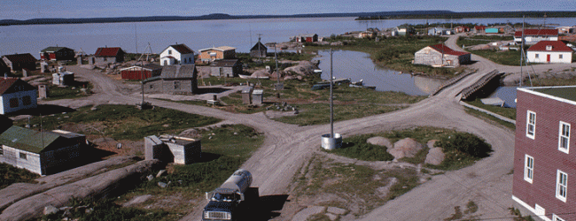
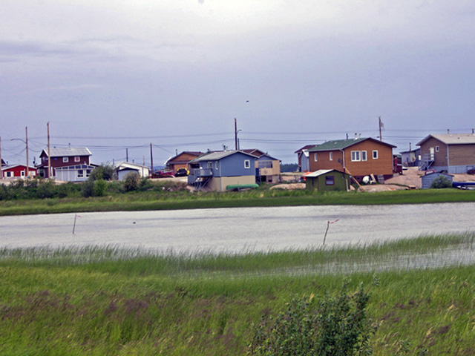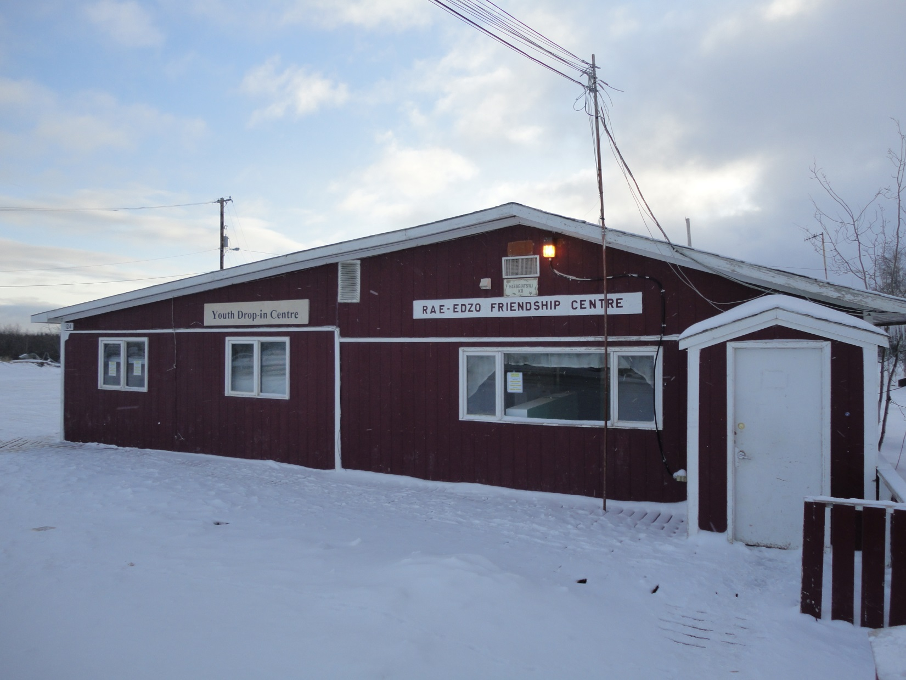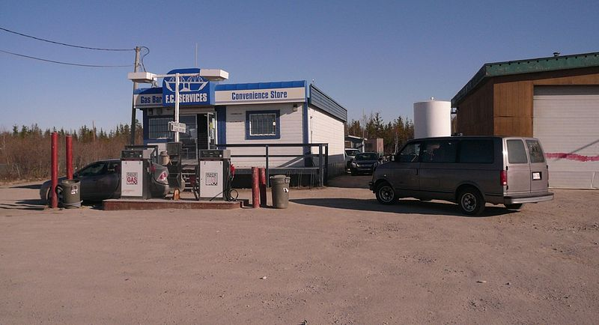
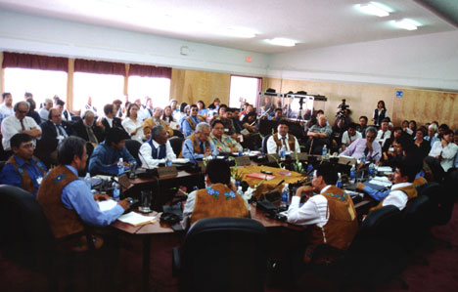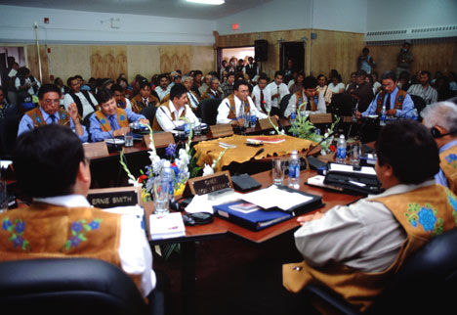

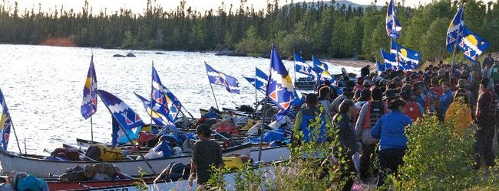
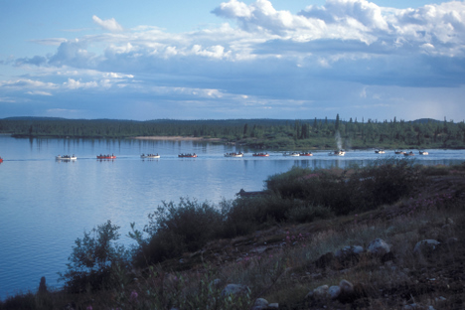
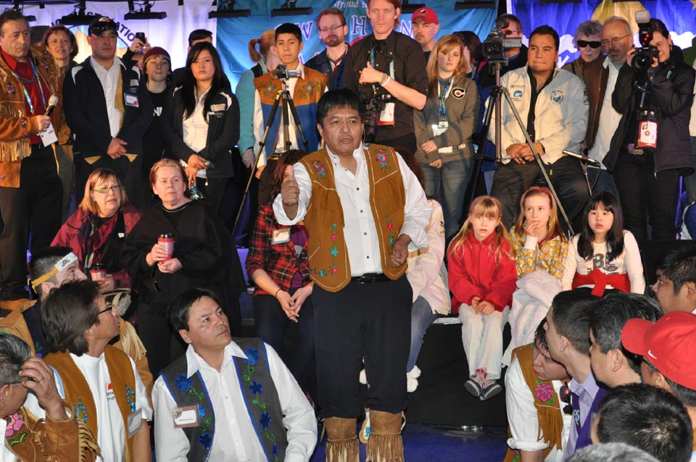

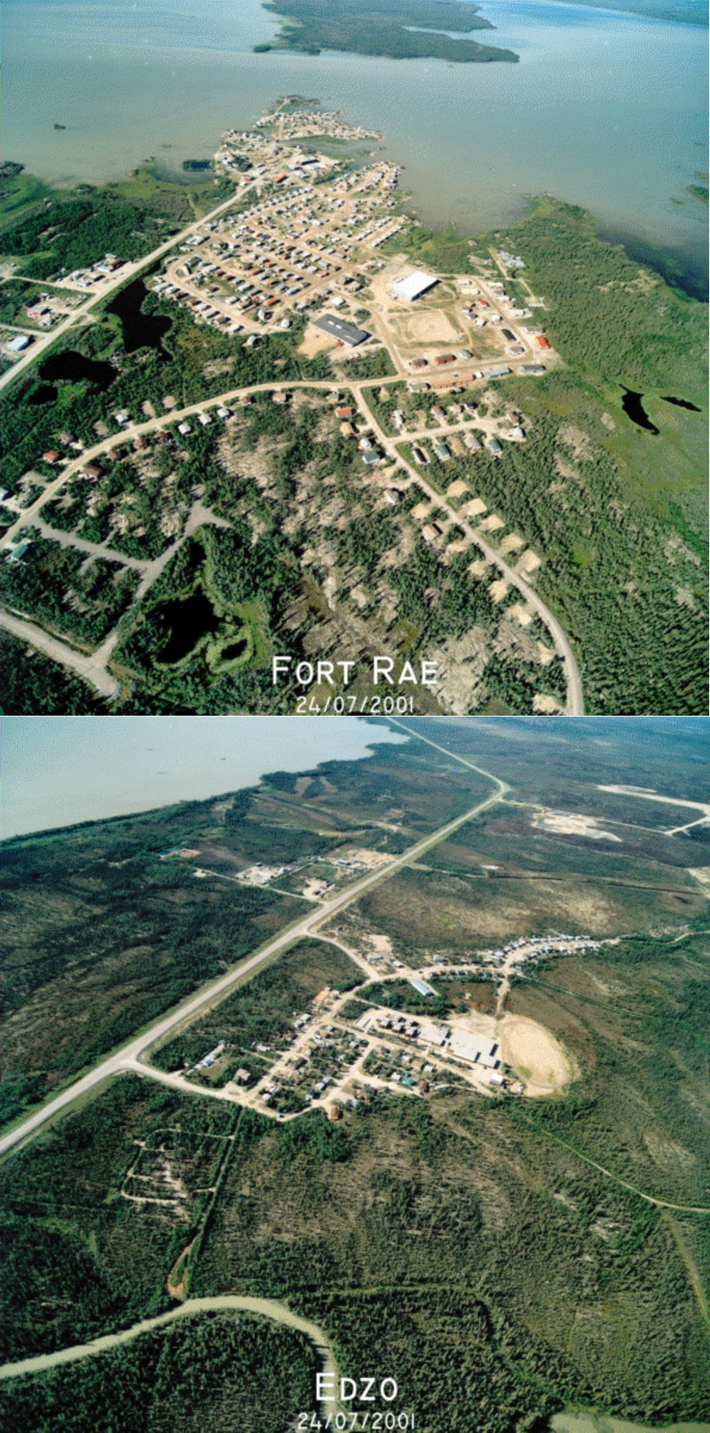
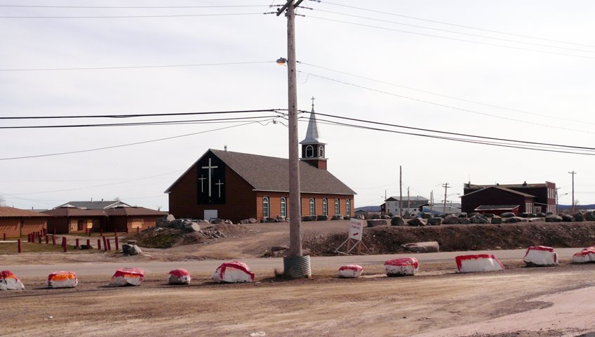
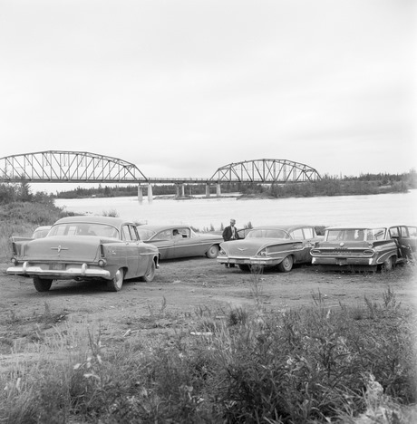

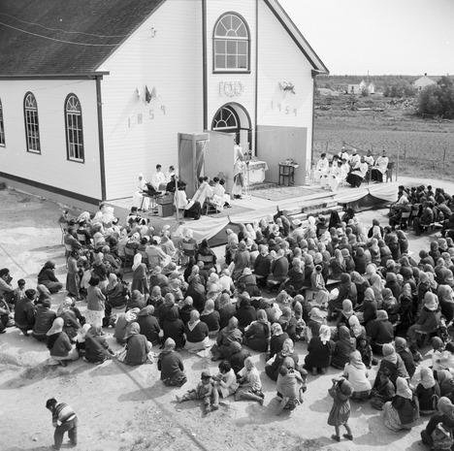
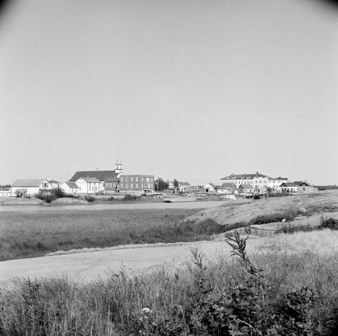

Jimmy Erasmus Seniors Home (Behchoko)

