**Traditional Food**

Traditionally, the Dogrib fished and hunted, subsisting chiefly on barren-ground caribou, which were trapped or speared. Moose, hare, fish, and migratory water birds were also important foods. The usual habitation of the Dogrib was a skin-covered tent, although in the hard winters they sometimes built wooden and brush-covered lodges. Their social organization consisted of many independent loosely led bands, each with its own territory. The [chief](http://www.britannica.com/EBchecked/topic/110749/chief) enemies of the Dogrib were the [Cree](http://www.britannica.com/EBchecked/topic/142354/Cree), [Chipewyan](http://www.britannica.com/EBchecked/topic/113112/Chipewyan), and [Yellowknife](http://www.britannica.com/EBchecked/topic/652757/Yellowknife). The Dogrib eventually massacred many Yellowknife in raids in the late 18th and early 19th centuries. Since that time the leaders of both groups have declared peace.

The Dogrib remained relatively isolated until the mid-20th century, when improved transportation and communication facilities brought them into greater contact with other parts of Canada. Dogrib descendants numbered more than 3,000 in the early 21st century.

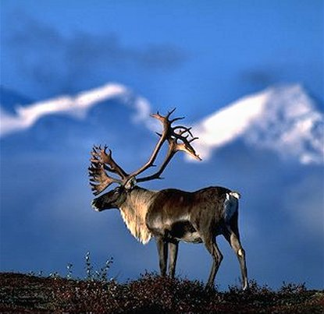

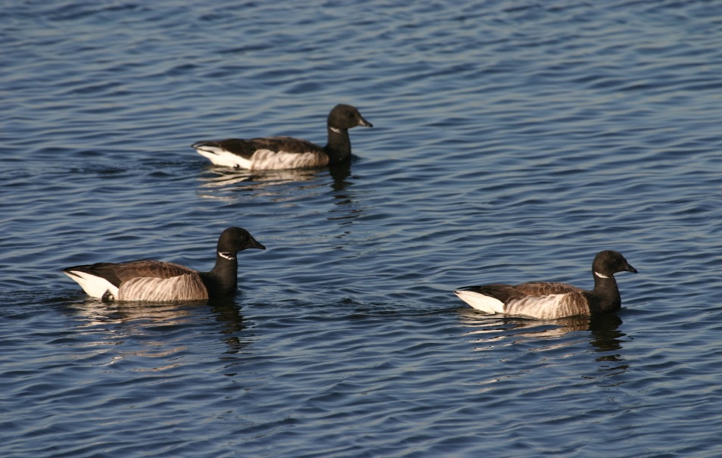

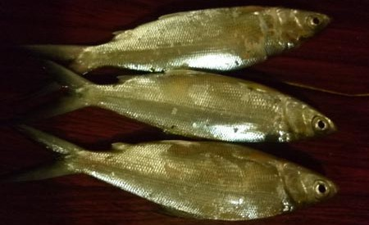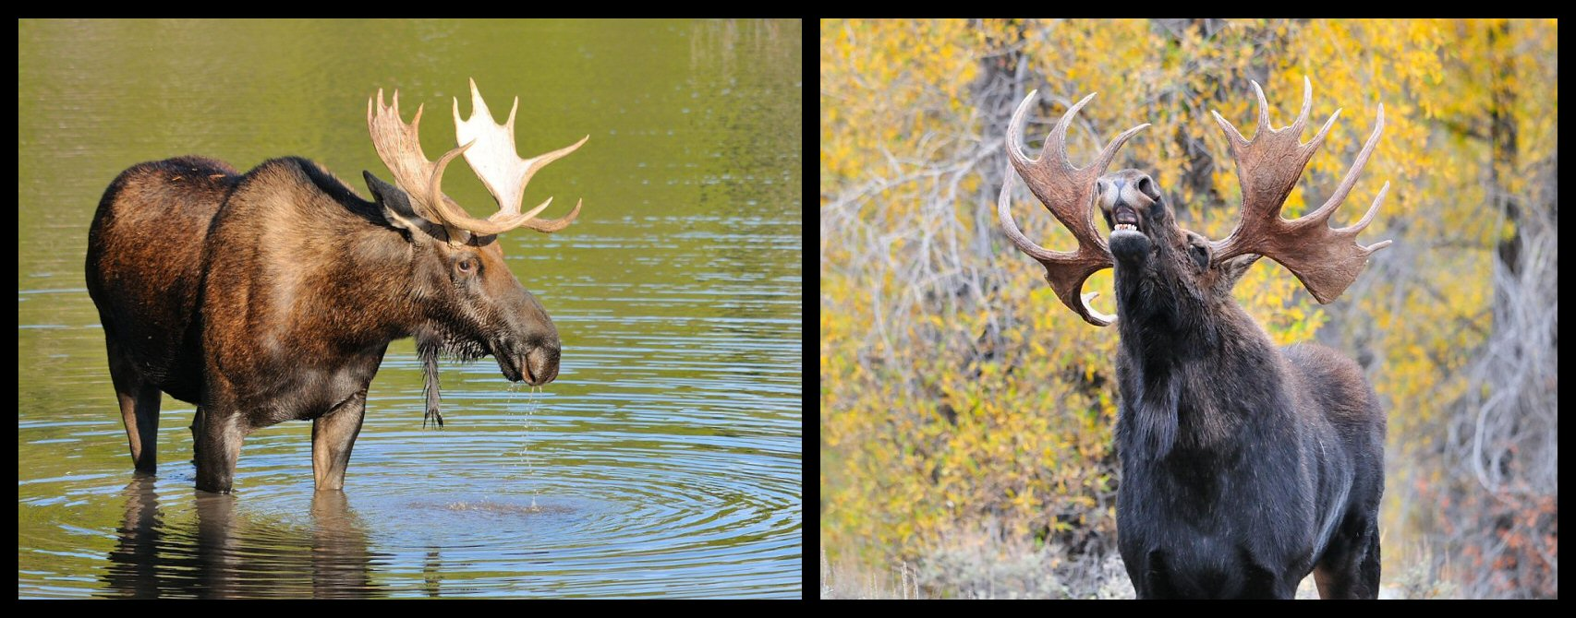

[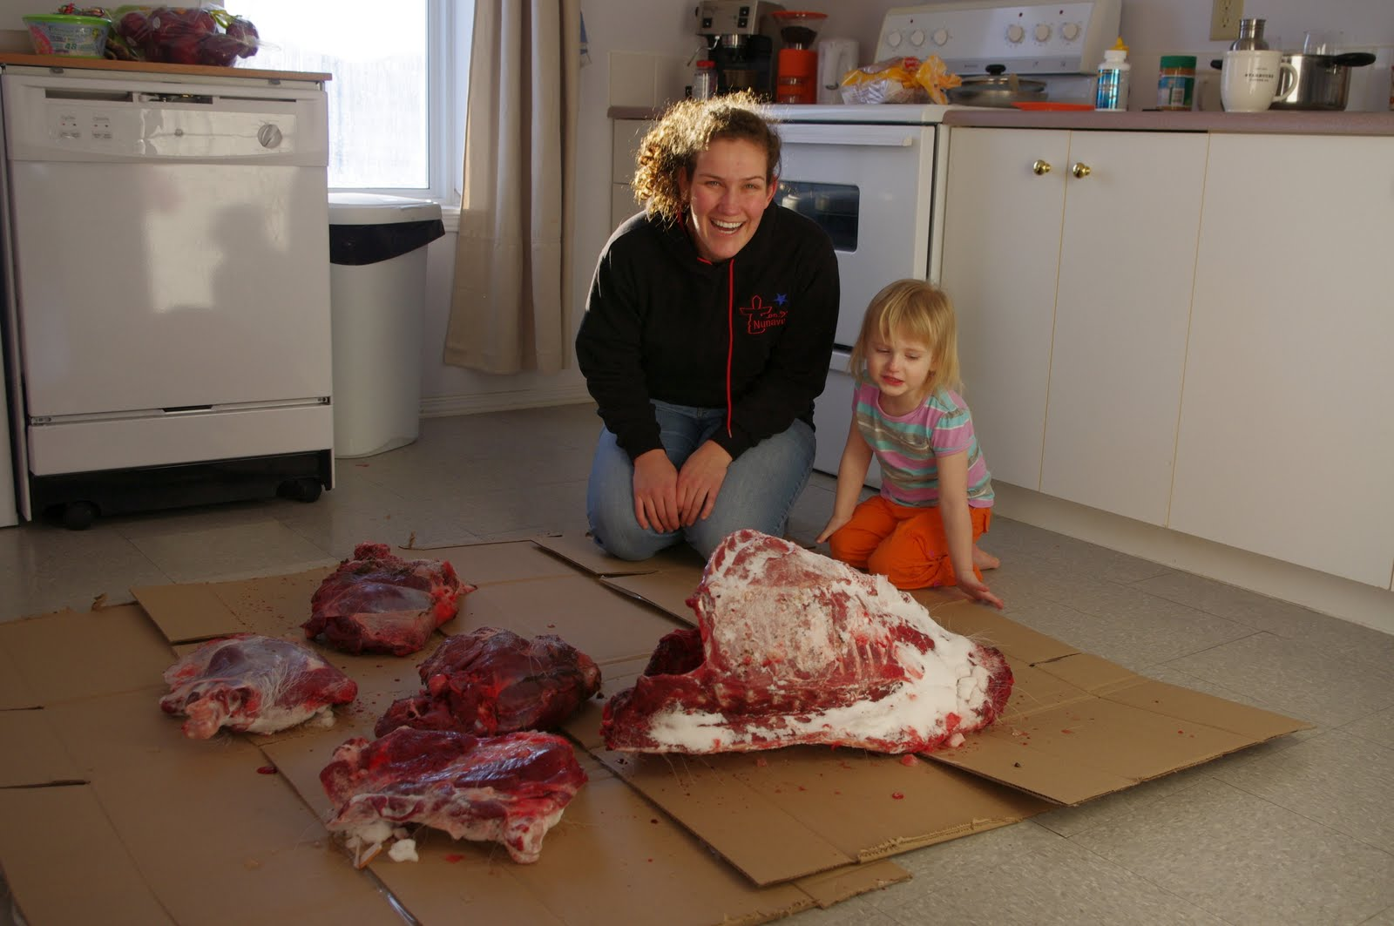](http://www.google.ca/url?sa=i&rct=j&q=&esrc=s&frm=1&source=images&cd=&cad=rja&docid=7AgzrMrAnbKJ1M&tbnid=57zJ3w4d5IHF_M:&ved=0CAUQjRw&url=http://spiritededucators.blogspot.com/2011_03_01_archive.html&ei=4hl5UrGpMKOhiALu7IA4&psig=AFQjCNEkY6dhqb5LuaaMr5YMrWLr_6vG4Q&ust=1383754555779446)

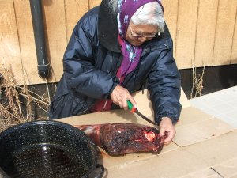

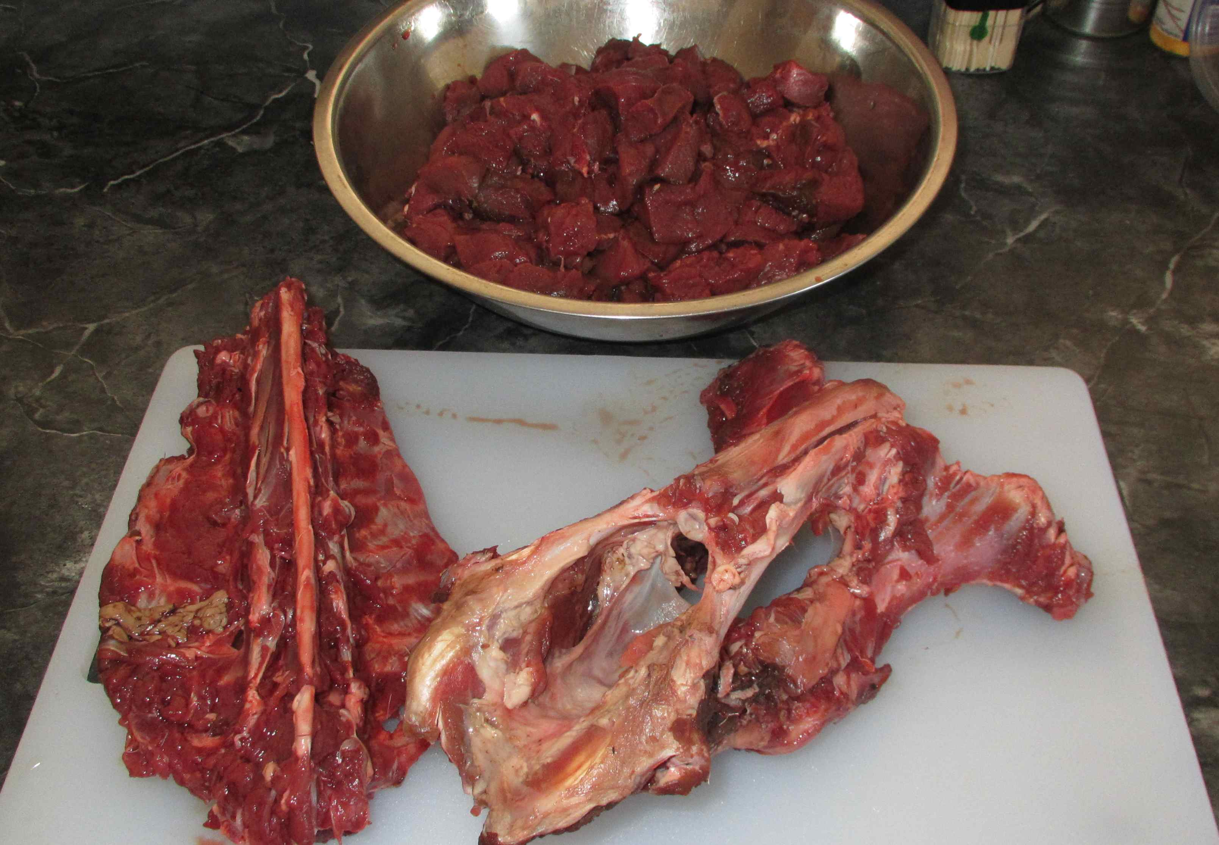

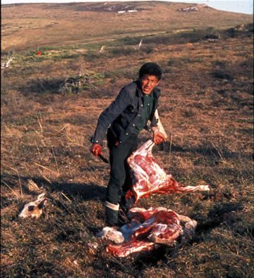

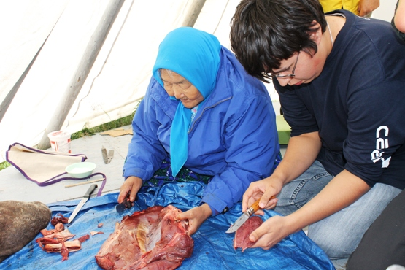

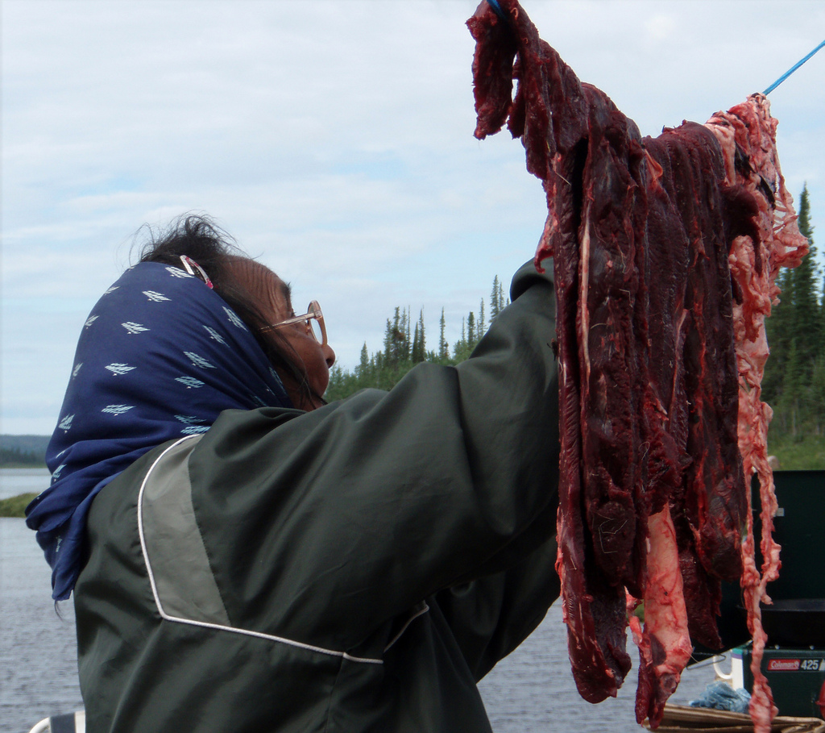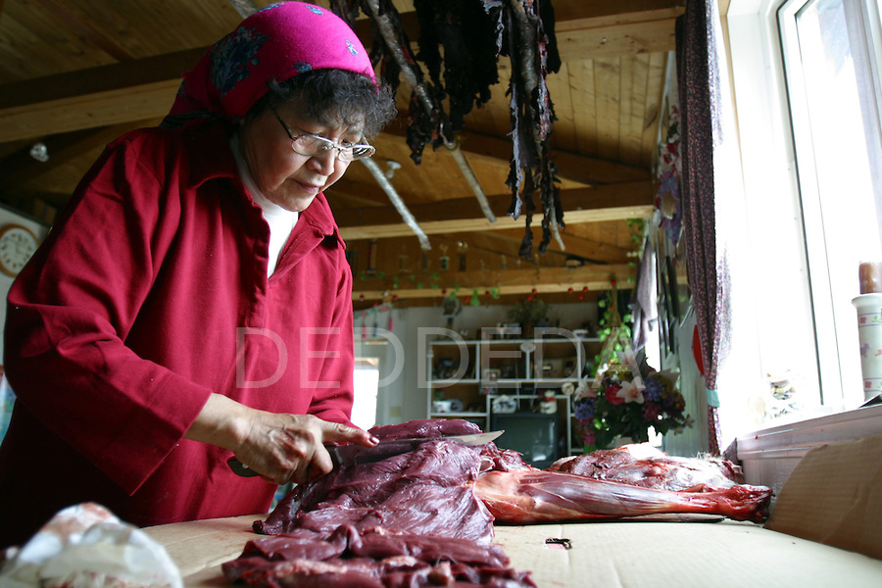[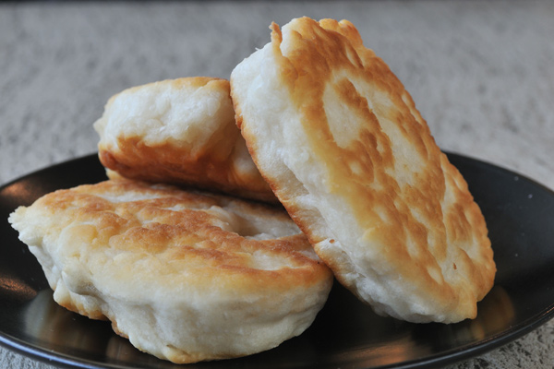](http://www.google.ca/url?sa=i&rct=j&q=&esrc=s&frm=1&source=images&cd=&cad=rja&docid=yraGm_2fadjZaM&tbnid=j56aVNb-l7NVhM:&ved=0CAUQjRw&url=http://www.upmagazine.com/blog/bannock-canada-s-bread&ei=I0h5UrG4CIrwiwLo9YHIDQ&bvm=bv.55980276,d.cGE&psig=AFQjCNG_2An0e6ZgvTj4rbfBXi-SQqGPzQ&ust=1383766426331689)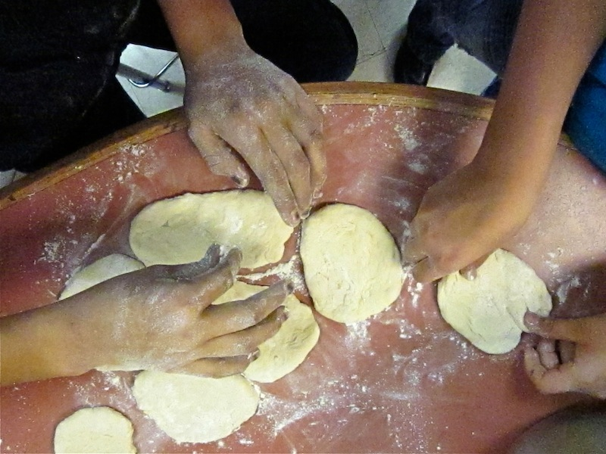

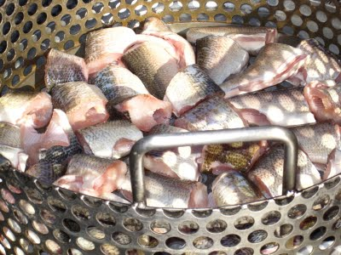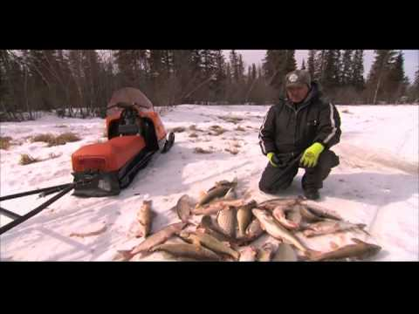

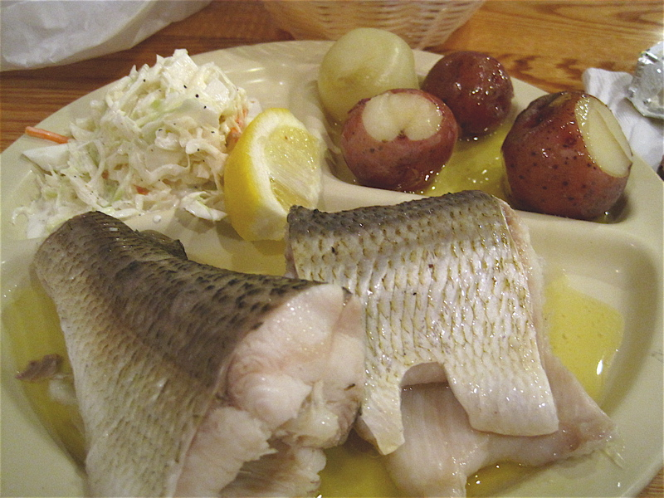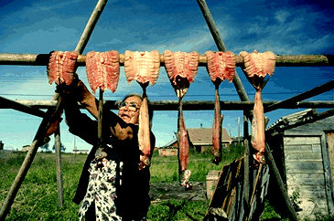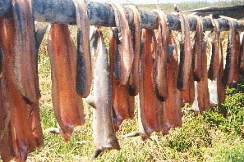

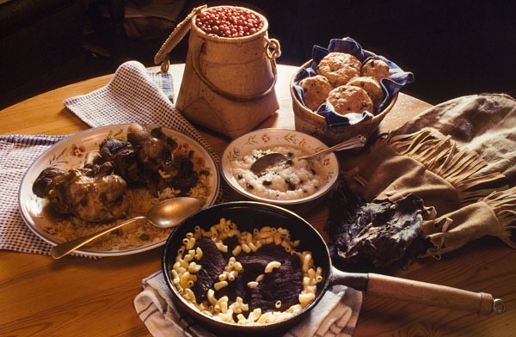

[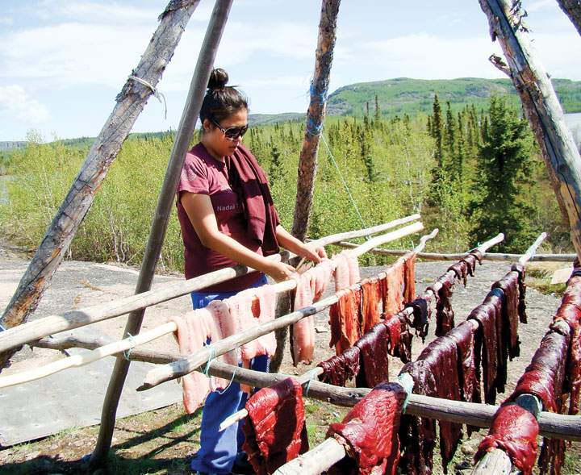](http://www.google.ca/url?sa=i&rct=j&q=&esrc=s&frm=1&source=images&cd=&cad=rja&docid=tSrgd_Jnc87V9M&tbnid=NEwPuTve1mrXQM:&ved=0CAUQjRw&url=http://norj.ca/2013/06/imbe-student-program-incorporates-tlicho-language/&ei=4CN5Utj3A8SujAKBtoHwDg&psig=AFQjCNEEuNQjjyXCI6MEqtFT6XF2OgN7xA&ust=1383757121924550)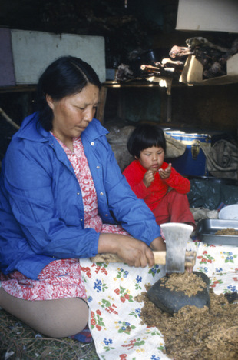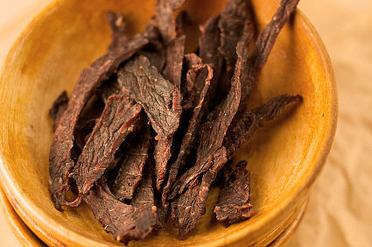

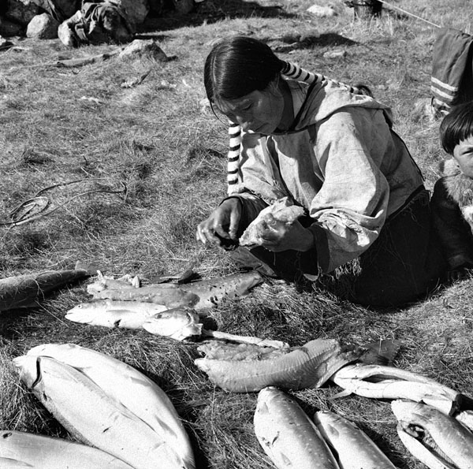

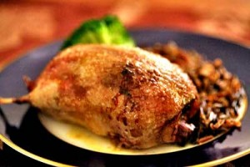[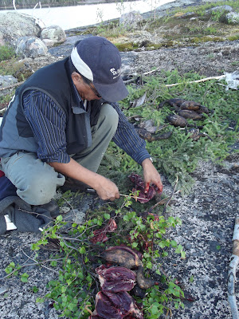](http://4.bp.blogspot.com/-81tgMpHX0X4/UFOktNhk4oI/AAAAAAAAAF8/_90S8uKpvlw/s1600/DSCF3087.JPG)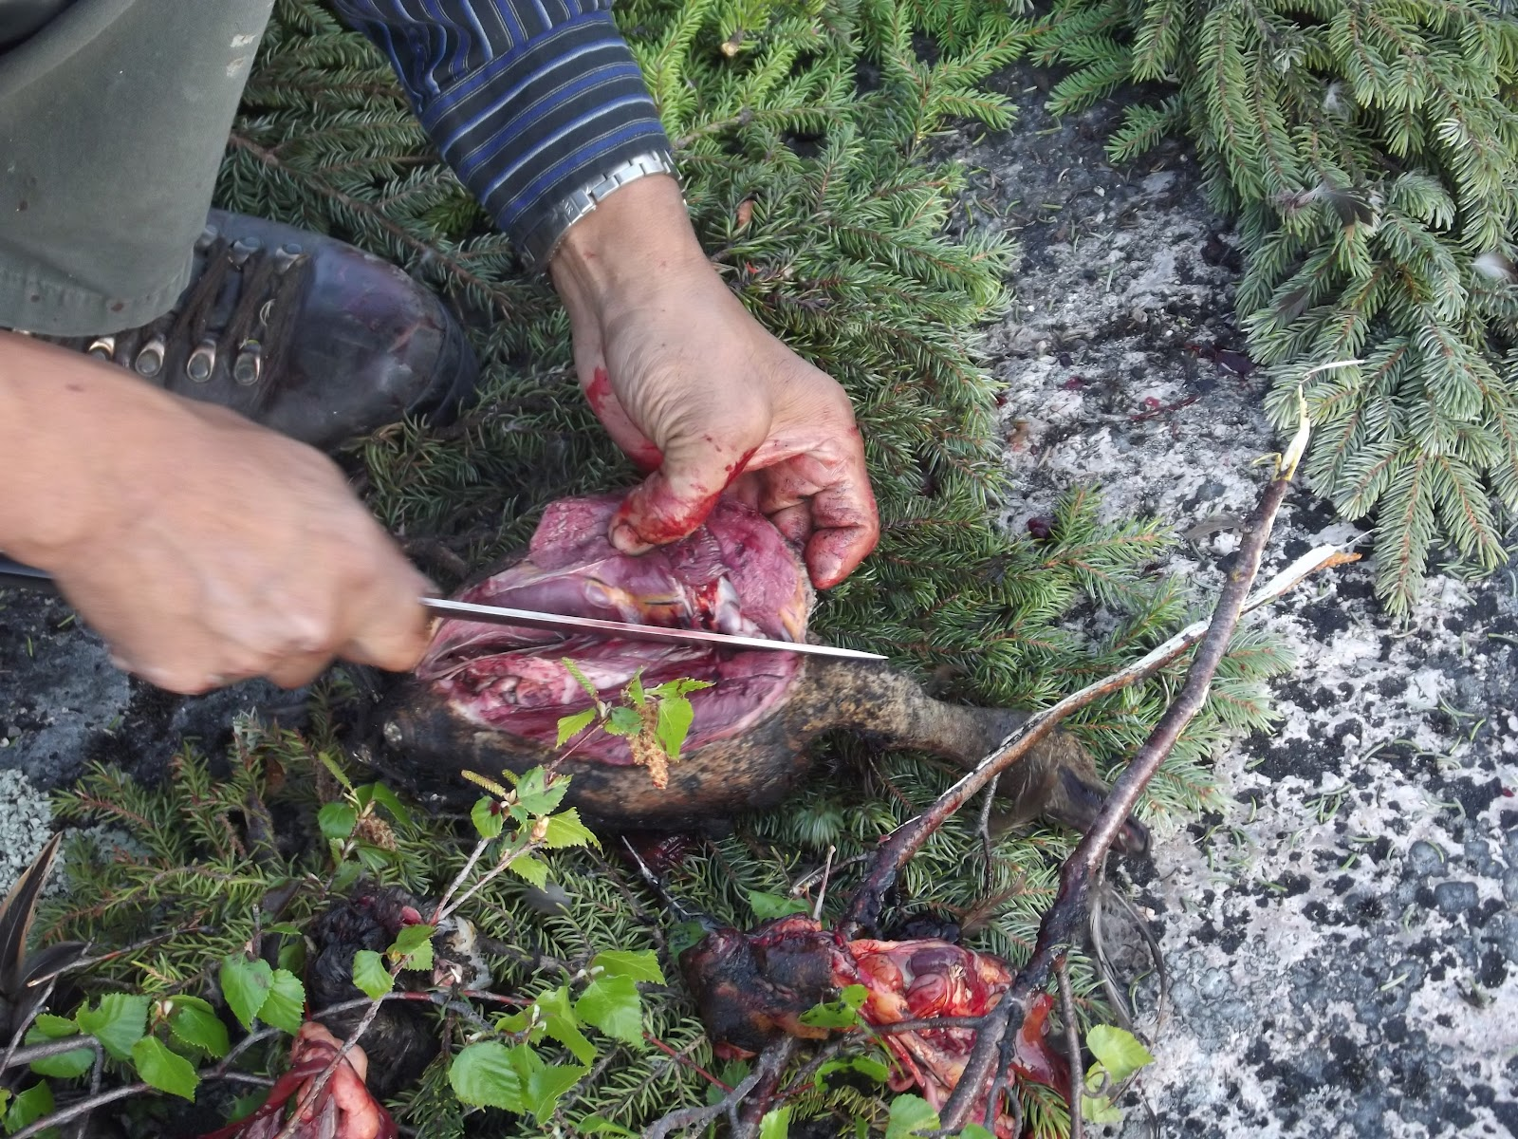

[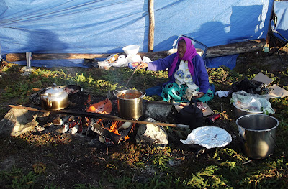](http://2.bp.blogspot.com/-jeu9XawCyEU/UFS6M-Z3PDI/AAAAAAAAAI4/HRttQqPf-34/s1600/DSCF3650+-+Copy.JPG)